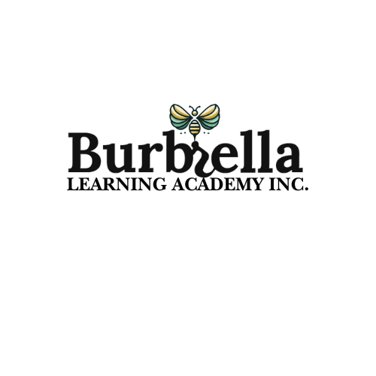

Burbrella Learning Academy Curriculum Map

**2nd Semester**

**January 2025 - Reading/ ELA**

| **Implementation**  *Use this table to keep track of student learning - K-1st* | | |
| --- | --- | --- |
| **Implementation - Learning Approaches**  **Nature:**   * Create Nature-Inspired Stories: After reading books about nature (such as "Leaf Man" by Lois Ehlert), students can gather natural materials like leaves, twigs, and flowers to create their own nature-inspired stories. They can then present their stories to the class.   **Play:**   * **Storytelling Puppets:** Provide students with simple puppets (either purchased or made from socks or paper bags) and ask them to retell a story or create new ones using their puppets. This promotes imagination, vocabulary development, and fluency.   **PBL:**   * **Create a Class Storybook:** Students can work together to create a class storybook. After reading a book, each child can draw pictures or write a few words to contribute to the story. The project might include different sections where students explore key elements such as character, setting, and plot. This helps develop comprehension and storytelling skills while fostering collaboration.   **SEL:**   * Feelings Book: Create a class "Feelings Book" where students draw pictures of different emotions and associate them with specific characters or scenes from a story. This can be used to help students understand and express their own emotions.   **Vocabulary:**   * Hello * Age * Appear * Artist * Autumn * Bay * Beak * Bloom * Bumpy * Burst * Buzz | ***Goals*** | |
| ***Students will be able to use their learning to…***  **Reading Comprehension**: Retelling stories with beginning, middle, and end; identifying main ideas, characters, and settings.  **Phonics**: Continuing to decode and encode words with blends, digraphs (e.g., "ch," "sh"), and vowel teams (e.g., "ai," "ea").  **Fluency**: Building fluency by reading simple texts with expression and accuracy. | |
| ***Making Meaning*** | |
| **UNDERSTANDINGS**  ***Students will understand that…***   * With prompting and support, ask and answer questions about key details in a text. * With prompting and support, retell familiar stories, including key details. * With prompting and support, identify characters, settings, and major events in a story. * Distinguish long from short vowel sounds in spoken single-syllable words. | **ESSENTIAL QUESTIONS**   * Can learners identify main topics? * What are the assessments being made in the classroom? * How are you implementing the learning approaches in core content areas? |
| ***Acquisition*** | |
| **KNOWLEDGE**  ***Students will know…***   * Use the illustrations and details in a text to describe its key ideas. * Identify basic similarities in and differences between two texts on the same topic (e.g., in illustrations, descriptions, or procedures). * Compare and contrast the themes, settings, and plots of stories written by the same author about the same or similar characters (e.g., in books from a series) | **SKILLS**  ***Students will be able to…***   * Ask and answer questions about key details in a text. * Identify the main topic and retell key details of a text. * Describe the connection between two individuals, events, ideas, or pieces of information in a text. |
|  | | |
|  | | |



Burbrella Learning Academy Curriculum Map

**2nd Semester**

**January 2025 - Math**

| **Implementation**  *Use this table to keep track of student learning - K-1st* | | |
| --- | --- | --- |
| **Our Natural World**  **Focus:** Connection with immediate environment.  **Nature:** Math in nature taps into students’ curiosity about the natural world while reinforcing key concepts.   * Collect natural objects (leaves, rocks, sticks) to count, sort by size or shape, and group into sets for addition and subtraction problems. * Create patterns using natural materials (e.g., stick-leaf-stick or rock-rock-leaf).   **Play:** Play-based math involves hands-on games, imaginative activities, and open-ended exploration where math concepts emerge naturally.   * Hopscotch Counting: Write numbers 1-20 on the ground and have kids hop to the number you call out. * Math Obstacle Course: Create stations where students complete math tasks like sorting objects, counting jumps, or solving a simple equation to move to the next station.   **PBL:** Projects give students meaningful, real-world contexts to apply their math skills.   * Count, compare, and graph data about the types or numbers of plants, insects, or birds observed outside.   **SEL:** Encourage teamwork by solving math problems collaboratively.   * Develop perseverance by working through challenges in games or puzzles. * Build confidence by celebrating small successes and promoting a growth mindset (“I can’t do it *yet*”). | ***Goals*** | |
| ***Students will be able to use their learning to…***  **Number Sense**: Building fluency with numbers up to 20 (K) or 100 (1st), including addition and subtraction.  **Place Value**: Understanding tens and ones (1st grade).  **Measurement and Data**: Comparing lengths, weights, and capacities; reading simple graphs.  **Geometry**: Identifying and describing shapes in the environment (e.g., hexagons, triangles, etc.). | |
| ***Making Meaning*** | |
| **UNDERSTANDINGS**  ***Students will understand that…***   * Count, read, and write numbers to 120. * Understand place value for two-digit numbers (tens and ones). * Use number lines to identify and order numbers. * Solve simple addition and subtraction problems within 10 using objects, fingers, or drawings. * Understand concepts of "adding to" and "taking away." | **ESSENTIAL QUESTIONS**   * How can students relate math in real world experiences? * Can students use manipulatives to aid their learning? * How can students participate in their own learning? |
| ***Acquisition*** | |
| **KNOWLEDGE**  ***Students will know…***   * Kindergarteners: Count to **50**, identify numbers up to **20**, solve basic addition/subtraction to **5**, and describe basic shapes. * 1st Graders: Add/subtract within **10-20**, count to **120**, understand place value, and compare numbers and shapes. | **SKILLS**  ***Students will be able to…***   * Explore open-ended problems using hands-on tools (e.g., “How many ways can you make 10?”). * Apply math to real-life scenarios, like sharing food or dividing resources during play. |
| ***Vocabulary*** | | |
| * **Add** * **Plus** * **Sum** * **Subtract** * **Minus** * **Take away** * **Equals** * **Altogether** * **Compare** * **Difference** | | |